MARKING KEY (PAPER I)

- m1
m1
m1
A1
- 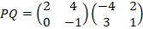
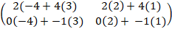
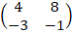
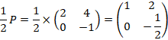
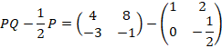
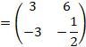

Domain
Domain Range
3
4
2
5

- 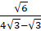
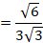
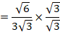
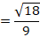
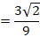
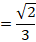

- 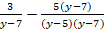
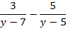
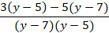

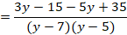

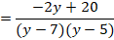
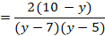

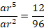
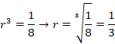
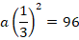
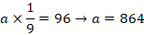
OB = OC = 10cm(radii)
OB² = OD²+DB²
10²=8²+DB²

Marks | Frequency | Cumulative  frequency
10 | 13 | 13
20 | 7 | 20
30 | 5 | 2 5
40 | 15 | 40
50 | 8 | 48
60 | 12 | 60
70 | 10 | 70
80 | 11 | 81
90 | 9 | 90

Total 90
Median = 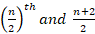
45th and 46th
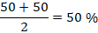
- 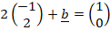
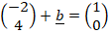
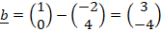

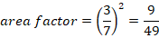
Area factor of the trapezium QABR
=
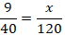
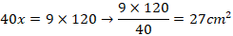
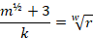
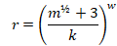

Acceleration

At

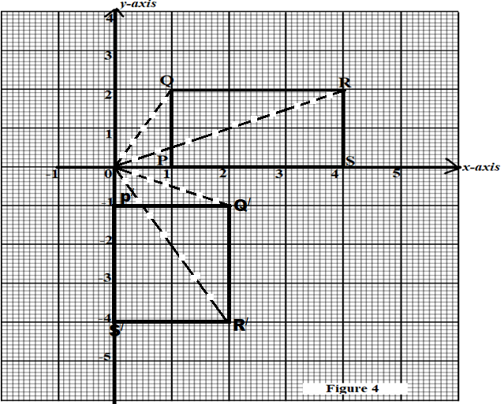
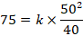

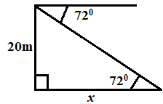
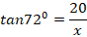
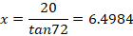

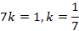

- Total outer hemispherical area =
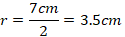
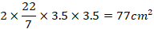

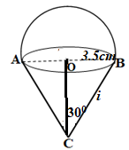

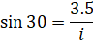
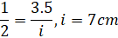

Currved surface area of the cone 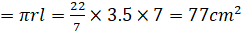
Total surface area =

